**1B ANOVA**

**Introduction**

If you want to determine whether there are any statistically significant differences between the means of two or more independent groups, you can use a one-way analysis of variance (ANOVA).

**Assumptions**

Assumption #1: You have one dependent variable that is measured at the continuous level.

Assumption #2: You have one independent variable that consists of three or more categorical, independent groups.

Assumption #3: You should have independence of observations, which means that there is no relationship between the observations in each group of the independent variable or among the groups themselves.

Assumption #4: There should be no significant outliers in the three or more groups of your independent variable in terms of the dependent variable.

Assumption #5: Your dependent variable should be approximately normally distributed for each group of the independent variable.

Assumption #6. You have homogeneity of variances (i.e., the variance of the dependent variable is equal in each group of your independent variable).

**Null and alternative hypotheses**

The null hypothesis for a one-way analysis of variance is:

H0: all group population means are equal (i.e., µ1 = µ2 = µ3 = ... = µk)

where µ = population mean and k = number of groups.

HA: at least one group population mean is different (i.e., they are not all equal)

**Dataset and Problem**

A researcher believes that different types of plant treatments lead to variations in plant growth. To test this theory, the researcher procured 30 plant samples and applied different treatments to them. The plants were categorized into three groups based on the treatment they received: namely, “ctrl” (control), “trt1” (treatment 1), and “trt2” (treatment 2). These groups (types of plant treatment) formed an independent variable called group. The growth of the plants was measured by the weight of each plant, which served as an indicator of plant growth. This dependent variable was called weight. The researcher would like to know if plant weight is dependent on the type of treatment it received. In variable terms, is mean weight different for different levels of group?

**Checking of Assumptions**

Assumption #1: You have one dependent variable that is measured at the continuous level.

**Remark.** The dependent variable is called 'weight' and is continuous level.

Assumption #2: You have one independent variable that consists of two categorical, independent groups.

**Remark.** The independent variable is 'group' which is categorized into independent groups: ctrl, trt1, trt2.

Assumption #3: You should have independence of observations.

**Remark.** The observations in each group of the independent variable or between the groups themselves do not affect one another. Since they are not related, then the observations are independent.

Assumption #4: There should be no significant outliers in the three or more groups of your independent variable in terms of the dependent variable.

#### Raincloud plots

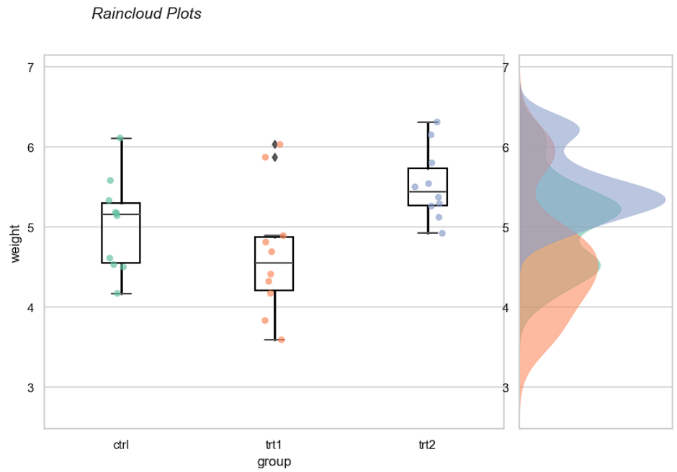

**Remark.** As observed from the boxplots, there are significant outliers in treatment 1. However, they are legitimate data entries and did not affect the results of the test so they are kept.

Assumption #5: Your dependent variable should be approximately normally distributed for each group of the independent variable.

**Remark.** Since *p > 0.05* by the Shapiro-Wilk's test in all 'group', then the variable 'weight' is approximately normally distributed for each of them.

Assumption #6. You have homogeneity of variances (i.e., the variance of the dependent variable is equal in each group of your independent variable).

**Remark.** Since *p > 0.05* by the Levene's test, then there was a homogeneity of variances of 'weight' for all 'group.'

**Computation**

**Reporting.**

A one-way ANOVA was conducted to determine if plant weight was different across different treatment groups. Plants were classified into three groups: control (n = 10), treatment 1 (n = 10), and treatment 2 (n = 10). There were outliers as assessed by visual inspection of the boxplots, but the results were not affected by these; data was normally distributed for each group, as assessed by Shapiro-Wilk test (p > 0.05); and there was homogeneity of variances, as assessed by Levene's test of homogeneity of variances (p = .341). Data is presented as mean ± standard deviation. Plant weight was statistically significantly different between the different treatment groups, F(2, 27) = 4.85, p = 0.016, η²p = 0.26. Plant weight increased from treatment 1 (M = 4.661, SD = 0.794) to the control group (M = 5.032, SD = 0.583) and treatment 2 (M = 5.526, SD = 0.443) groups, in that order. Note that not only was treatment 1 the least effective, but it also decreased plant growth compared to the control group. Tukey post hoc analysis revealed that the mean increase from treatment 1 to treatment 2 (0.865, 95% CI [0.174, 1.556]) was statistically significant (p = 0.012), but no other group differences were statistically significant.